Abstract
Tongue Image Analysis for Covid-19 Diagnosis and Disease Detection
Sanjana Dulam¹, Varsha Ramesh², Malathi G³
¹ Vellore Institute of Technology, Chennai, India, sanjanadulam@gmail.com
²Vellore Institute of Technology, Chennai, India, varsharamesh82@gmail.com
³Vellore Institute of Technology, Chennai, India, malathi.g@vit.ac.in

Tongue analysis is an effective indicative strategy for assessing the state of the internal organs and to detect associated diseases. In this paper, we propose a disease detection method with the use of a regular smartphone and to track disease on the go. Colour, texture and geometric features are extracted from the images of the tongue captured and are used to train classification models to detect associated diseases. The primary objective of this paper is to classify images of tongues which are healthy or are diagnosed with either thyroid, heart disease or gastritis. The secondary objective is to perform comparative analysis of machine learning algorithms to find the best performing models and their differences in hope to achieve better performance than those which have been achieved till date. In addition, this paper also takes into consideration the recent breakout, COVID-19, and aims to identify features which potentially help to classify tongues of patients who have been diagnosed with this pandemic.

Key words: Covid-19, Image Processing, Machine Learning, Segmentation, Smartphone

INTRODUCTION

In the current day scenario where human interaction is limited and early diagnosis of diseases is highly essential, it is of utmost importance to invest in and develop efficient and effective methods of diagnosis. With several people being hesitant or even unable to visit hospitals and doctors, they are unable to detect any medical conditions they have until it is too late. This paper therefore aims to bring forth a solution where people can easily be diagnosed for common diseases by simply acquiring a picture of their tongue, a small body part capable of giving us profound insights, using their smartphone. This work aims to assist in examining an image of a tongue and draw conclusions, to support the specialist in framework without human intervention. The human tongue is capable of indicating signs of various illnesses which are reflected by its surface coating, texture, colour and geometric features. In this paper, we propose a computerised tongue inspection method based on quantitative and qualitative features such as area, height, width, colour and texture of the tongue. We extract these features from the tongue images by using popular digital image processing techniques. With the current pandemic, this paper also aims to investigate and
identify any correlation present between the tongue and diagnosis of COVID-19.
The structure of the paper is as follows: Section 2, Literature survey, discusses related work done by previous authors. Section 3, Data description, describes the data collected and used in this study. In section 4, our proposed idea is described in detail followed by the methodology used. A comparative study of the classifiers built is discussed. Finally, the results achieved and further findings are presented.

2. LITERATURE REVIEW

The authors of [1] had focused on a group of 100 local patients affected by 13 common diseases focusing mainly on diabetes. They made use of support vector machines for classification. In [2] the author used gradient vector flow and watershed transformation to produce better edge detection to select oral bacteria present in saliva and tongue-coating. In [3], the authors had created a framework that performs twisted division by applying the quickened mean move calculation to find diseases related to liver and stomach. Binary classification between strep and healthy throats using a robust throat color analysis technique called YCbCr color is discussed in [4]. In [5], geometric features and the Sparse Representation Classifier (SRC) is used to detect various diseases. The extracted features in [6] are confined to the middle region of the tongue, as this corresponds to the stomach organs and they use these to detect stomach related diseases. Different tongue shapes like circle, rectangle and triangle had indicated the presence of certain pathologies which is what the study in [7] shows using the SVM classifier. In [8], they aimed to achieve fast and less complex making the system apt for mobile devices executing automatic tongue diagnosis entailing clinical decision support system. Analysing the performance of different colour models, RGB was unveiled to have a better enactment than others. The use of Bayesian network on quantitative features of the tongue were successful in mapping the tongue to six diseases in [9]. [10] uses an automated methodology to analyze and detect hepatitis by using tongue images analysis based on genetic algorithm–support vector machine.[11] employs a framework comprising of image acquisition, image segmentation, body and coat segmentation, colour classification and a neural network. A MobileNet model was used by applying transfer learning to create a skin disease classification
system on Android application proposed in [12].

3. DATA DESCRIPTION

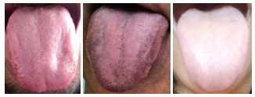
For the purpose of this study, tongue images of people aged from 18 to 70 years old were collected along with information regarding their medical condition i.e. if they have diseases.
Figure 1: Three sample tongue images from the dataset for healthy, heart disease and Covid-19 respectively.

This study is focused on sample individuals belonging to the Indian subcontinent. A total of 109 images were collected of which 53 were healthy with no diseases while the other 56 were diagnosed with one or more medical conditions. Of these, 21 had thyroid, 16 with gastritis, 15 with heart problems and 13 with Covid-19. 47% of our dataset i.e. 51 of the samples collected were from females while the other 53% i.e. 58 samples were from males. Figure 1 gives a sample of a healthy, diseased and Covid-19 diagnosed tongue.

4. Proposed work
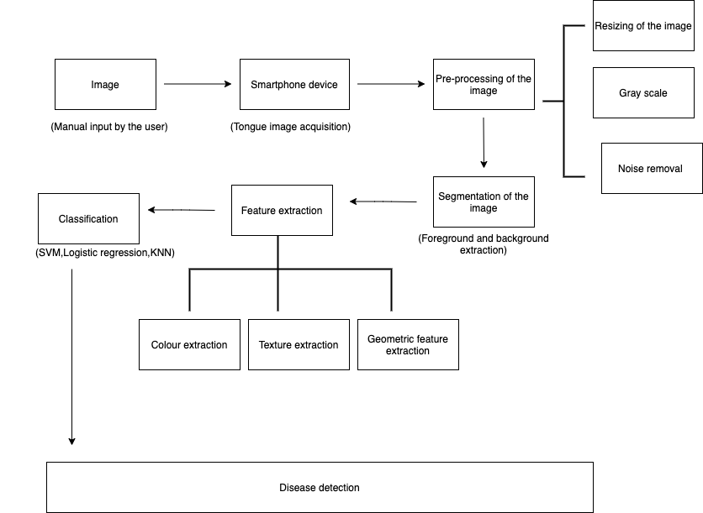
This paper attempts to detect diseases such as thyroid, heart disease, gastritis and Covid-19 using well known image processing techniques and machine learning algorithms. The images are passed through a pipeline in which they are first pre-processed and segmented after which various features are extracted. The extracted features are used to build classification models and detect the diseases in scope of this paper. The classification models to be built and compared are support vector classifier, KNN and logistic regression. A comparative study of the models is performed. Figure 2 is a flowchart of how disease detection is carried out.
Figure 2: Healthy tongue flowchart of how disease detection is carried out

5. Methodology

Image acquisition: The acquisition process involves obtaining the image by making use of a regular smartphone. We acquired 109 images among which 55 were male and 54 were female.

Image pre-processing: Images are resized to 560x560 for computational uniformity and model convergence. A grayscale conversion is done prior to appropriate feature being extracted. A five by five kernel is used as a 2D filter for noise removal.

Image segmentation: To segment the images foreground-background extraction using the GrabCut algorithm is shown in Figure 3. The Gaussian Mixture model is used for modelling the foreground and background by which the pixels in the region of interest are labelled and clustered.

The GrabCut algorithm is chosen over other methods due to the non-uniformity of the background. This algorithm performs well in such a condition and the reason lays at uncertainty principle where positions and frequencies of the signal cannot be determined at the same time.
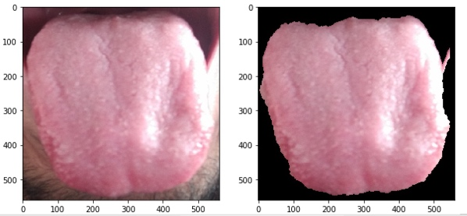

Figure 3: Healthy tongue before and after segmentation using foreground-background extraction

Extracting features: We have obtained a total of 11 features which include colour, texture and geometric features as indicated in Figure 5 and Figure 6. These features are then analyzed and compared with a knowledge base.

5.1 Chromatic Features

RGB values for 5 commonly observed colours in tongues are defined as reference values to which the pixels in the image will be compared. The Manhattan distance, as in (1), is calculated between the RGB values of the pixels and the base colour values. The colour of an image is therefore identified as the reference colour to which a majority of the foreground pixels have a minimum distance. Figure 4 shows the reference colours and RGB values as defined while figure 5 gives a few sample tongue images and their respective extracted colours.

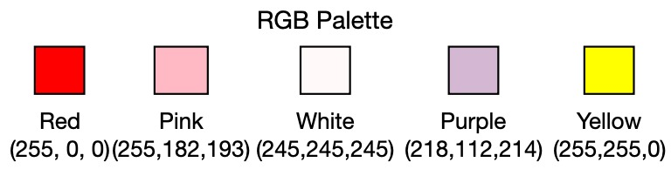

Figure 4: RGB values defined as base colours to which manhattan distance of pixels are calculated

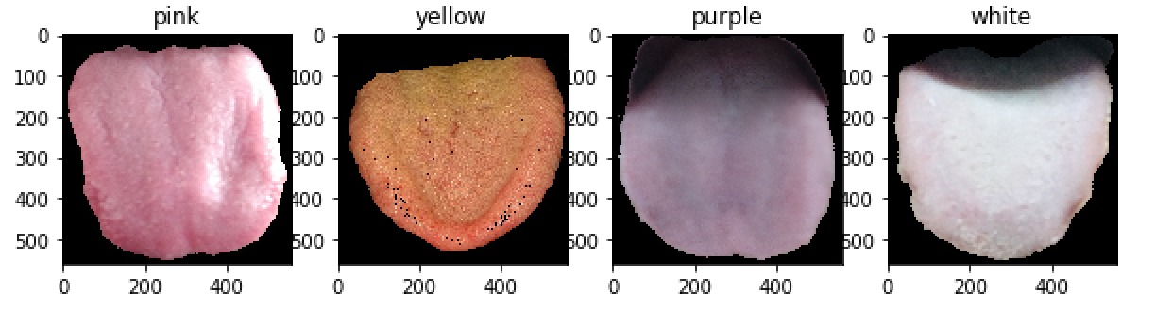

Figure 5: Tongue images with their predicted colours

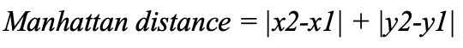
(1)

Colour inference:
A pink/red colour indicates a healthy tongue.
A coated tongue (white) indicates the possibility of thyroid (hypothyroidism) or covid-19.
A purple colour indicates the possibility of a heart disease. It is also known to show vitamin deficiency or insufficient oxygen in the blood.
A yellow colour indicates bacterial growth or a possible indication of gastritis.

5.2 Textural Features

Meaningful texture is extracted from the raw images which is used to identify coating, smoothness, lines and small pores each reflecting different pathological changes in the body. Figure 6 shows a sample of tongue images and the extracted textural features visible the respective binarized images.

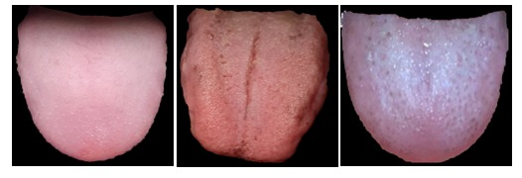
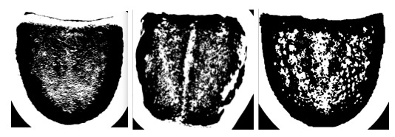

Figure 6: The top row of RGB images from left to right are healthy, thyroid and covid-19 tongues respectively. The bottom row of binary images, each corresponding to its original image above, shows the texture that has been extracted and made visible. The smooth tongue, the center line and the surface coating are visible in each of the respective images and these textural features are therefore used in making inferences about the diseases present.
Textural inference:
A smooth texture indicates a healthy tongue.
Lack of patina(coating) indicates the possibility of thyroid.
Gastritis is usually reflected in the form of a coating on the surface of the tongue.
More recently, white patches on the tongue have been found to be an indicative sign of covid-19

5.3 Geometric features
Various geometric features, including dimensions and their ratios, are extracted from the images in addition to the chromatic and textural features.

5.3.1 Area: Area is calculated by measuring the number of coloured pixels.
5.3.2. Height-width ratio(hw): It is the ratio of the height of the tongue(h) and the width of the tongue(w) as given in (2).
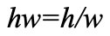
(2)
5.3.3. Central width: The width is measured as the horizontal distance from the central pixel to the farthest point on the x axis.
5.3.4. Central height: The height is measured as the vertical distance from the central pixel to the farthest point on the y axis.
5.3.5. Smaller half distance: Smaller half distance is the half distance of either the height or the width, the condition for it to be chosen is depending on which of them is shorter.
5.3.6. Circle area: It is defined as the area of the circle present on the palette of the tongue using the formula of the smaller half distance.
5.3.7. Circle area ratio: It is the ratio between the circle area and the area of the tongue.

6. Results and discussion
The features extracted from the images are used to build three different classification models, support vector classifier (SVC), Logistic Regression model and K-NN. Support Vector Machine are learning models which is used for classification and regression analysis. It is specifically used for supervised binary classification. It uses the concept of kernel trick to find an optimal boundary between the outputs. Logistic regression mainly focuses on classification. It is generally used for the prediction of binary outputs. It analyses the relationship between a dependent and an independent variable. KNN algorithm is when a search is performed on the training dataset to get the closest label for the data present in the dataset. We are choosing the nearest neighbours and find similar attributes which help us in classification.
The dataset is split in a 70-30 ratio where we use 70% of the data i.e. 76 samples as a part of our training data and 30% i.e. 33 samples as a part of our test set.

Upon fitting our data to the classifiers to detect Thyroid, we get the best results with SVC, as seen in Figure 7, giving us an accuracy of 85% followed by K-NN which gives an accuracy of 78% and Logistic Regression with 75%.

In detecting Gastritis, we get the best results with SVC and Logistic Regression, as shown in Figure 8, both giving us an accuracy of 93% followed by K-NN which gives an accuracy of 89%.

For Heart disease detection, as seen in Figure 9, we get the best results with SVC and K-NN, both giving us an accuracy of 89% followed by Logistic Regression which gives an accuracy of 78%

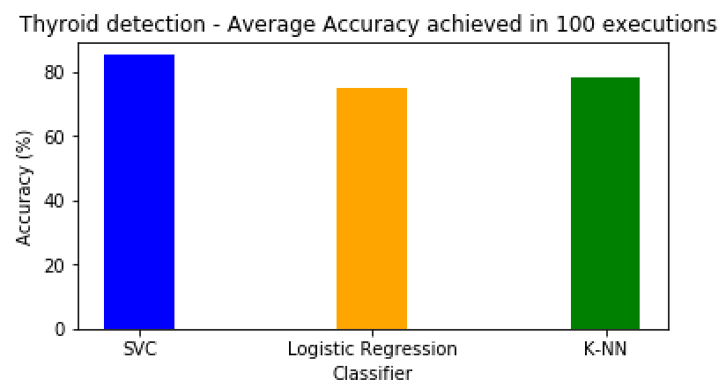
Figure 7: Comparative study between SVC, Logistic Regression Classifier and KNN to determine the accuracy of thyroid disease

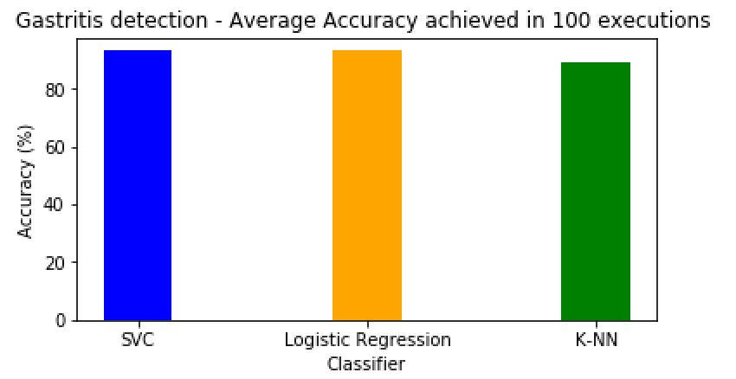
Figure 8: Comparative study between SVC, Logistic Regression Classifier and KNN to determine the accuracy of gastritis disease.

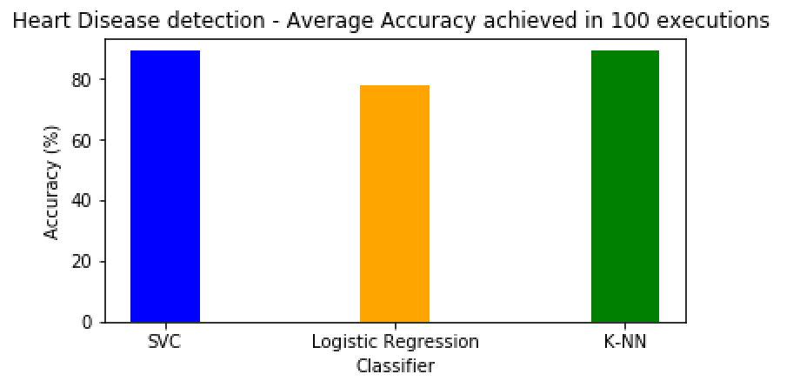
Figure 9: Comparative study between SVC, Logistic Regression Classifier and KNN to determine the accuracy of heart disease.
After critically analyzing the tongue images of covid-19 diagnosed patients and carrying out an extensive research we were able to identify a pattern in the colour and textural features where covid-19 patients often developed a white coating on the surface of their tongue. By using this inference, we were able to achieve an accuracy of 60% when fit to a Logistic Regression model. Table 1 indicates the values for precision, recall, f1 score and support, accuracy, macro and weighted average for the detection of covid-19 based on our model. In the given table, 1 indicates the presence of Covid-19 disease while 0 indicates otherwise.
After a thorough analysis and research we were able to exploit the features of a tongue’s digital image and detect the diseases which are of primary focus of this paper with satisfying results.

A more exploratory study with both computational power and human perception helped us identify, infer and establish a relation between the chromatic and textural features of the tongue with the diagnosis of the recent Covid-19 disease. This finding, although holding great potential in the fields of both medicine and intelligent diagnostic systems, is limited in its validity as the scope of study is not large enough to assertively confirm this relation. Further research in this aspect is highly encouraged as it could bring about great insights.

Table 1: Precision, recall, f1 score, support, accuracy, macro and weighted average for the detection of covid-19 based on our model.
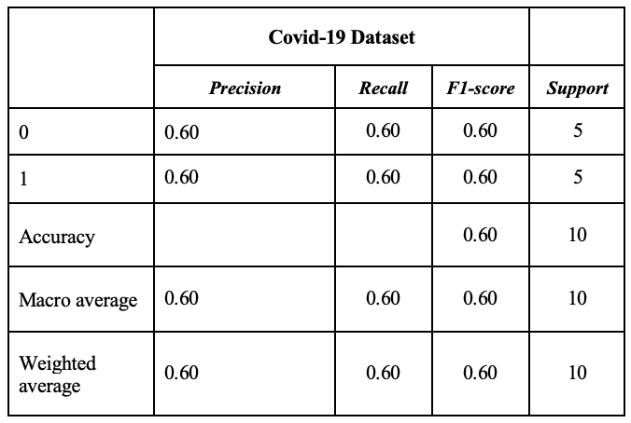
7. Conclusion
Thus, we can draw conclusions that the palette of the tongue and the health of the person are in correlation with each other. The images of the tongue are captured with the help of a smartphone. Various features such as colour, texture and geometric features were put into use and they were classified using different classifiers. Our system can be improved by including other edge detection algorithms and by implementing localized intensity methods.

ACKNOWLEDGEMENT

We extend our sincere thanks to the management, Vellore Institute of Technology, Chennai for providing continuous support and encouragement for completion of this work. We are indebted to the reviewers for their valuable suggestions.
References
- G. Uma Devi, T. Ravi, Disease Diagnosis for Various Signs using Tongue Color Image Segmentation, Australian Journal of Basic and Applied Sciences, 9(10), Pages: 341-348, 2015
- Tania MH, et al. Advances in automated tongue diagnosis techniques, Integrative Medicine Research,Volume 8,Issue 1,Pages:42-62,2018
- Devi, G. & Anita, Mary, A novel semi supervised learning algorithm for thyroid and ulcer classification in tongue image, Cluster Computing. 22. 10.1007/s10586-017-1417-z.
- Behnam Askarian, Seung-Chul Yoo, and Jo Woon Chong, Novel Image Processing Method for Detecting Strep Throat (Streptococcal Pharyngitis) Using Smartphone, Department of Electrical and Computer Engineering, Texas Tech University, Sensors 2019, 19, 3307;doi:10.3390/s19153307,www.mdpi.com/journal/sensors
- H. Zhang and B. Zhang, Disease Detection Using Tongue Geometry Features with Sparse Representation Classifier, 2014 International Conference on Medical Biometrics, Shenzhen, 2014, pp. 102-107
- Ratchadaporn Kanawong, Tayo Obafemi-Ajayi, Tao Ma,2 Dong Xu, Shao Li, and Ye Duan, Automated Tongue Feature Extraction for ZHENG Classificationin Traditional Chinese Medicine, Evidence-Based Complementary and Alternative Medicine Volume 2012, Article ID 912852, 14 pages doi:10.1155/2012/912852
- G. U. Devi and E. A. M. Anita, An analysis of tongue shape to identify diseases by using supervised learning techniques, 2017 International Conference on Information Communication and Embedded Systems (ICICES), Chennai, 2017, pp. 1-4
- M.H. Tania, K.T. Lwin, M.A. Hossain, Computational complexity of image processing algorithms for an intelligent mobile enabled tongue diagnosis scheme, 2016 10th International Conference on Software, Knowledge, Information Management & Applications (SKIMA). Chengdu: IEEE (2016), pp. 29-36
- Zhang, H. Z., Wang, K. Q., Zhang, D., Pang, B., & Huang, B. (2005). Computer Aided Tongue Diagnosis System. 2005 IEEE Engineering in Medicine and Biology 27th Annual Conference.
- N.Sandhya, M.Rajasekar, Tongue Image Analysis for Hepatitis Detection Using GA-SVM, Indian Journal of Computer Science and Engineering (IJCSE), Vol. 8 No. 4, Pages: 526-534, 2017
- Jessica Velasco, Jeshurun Rojas, John Peter Ramos, Hannah Mhel Muaña, Keith Louise Salazar, Health Evaluation Device Using Tongue Analysis Based on Sequential Image Analysis, International Journal of Advanced Trends in Computer Science and Engineering (IJATCSE), Volume 8, No.3, 2019, Pages: 451- 457, 2019
- Jessica Velasco, Cherry Pascion, Jean Wilmar Alberio, Jonathan Apuang, John Stephen Cruz Mark, Angelo Gomez, Benjamin Jr. Molina, Lyndon Tuala, August Thioac, Romeo Jr. Jorda, Smartphone-Based Skin Disease Classification Using MobileNet CNN, International Journal of Advanced Trends in Computer Science and Engineering (IJATCSE), Volume 8, No.5, 2019, Pages: 2632-2637, 2019

